Portfolio Decisions
First, you choose the assets in your portfolio from the left column below: equity (i.e. stocks), equity & bonds, or equity, bonds, and gold (we will talk about bonds and gold later). Then, you decide whether you want to be passive or active investor (will talk about what this means shortly). If you are passive, then you would invest in ETFs and index funds only. If you are active, then you will invest in stocks as well. An active investor is the one who tries to beat the market. We will talk shortly about why we don’t include mutual funds here.
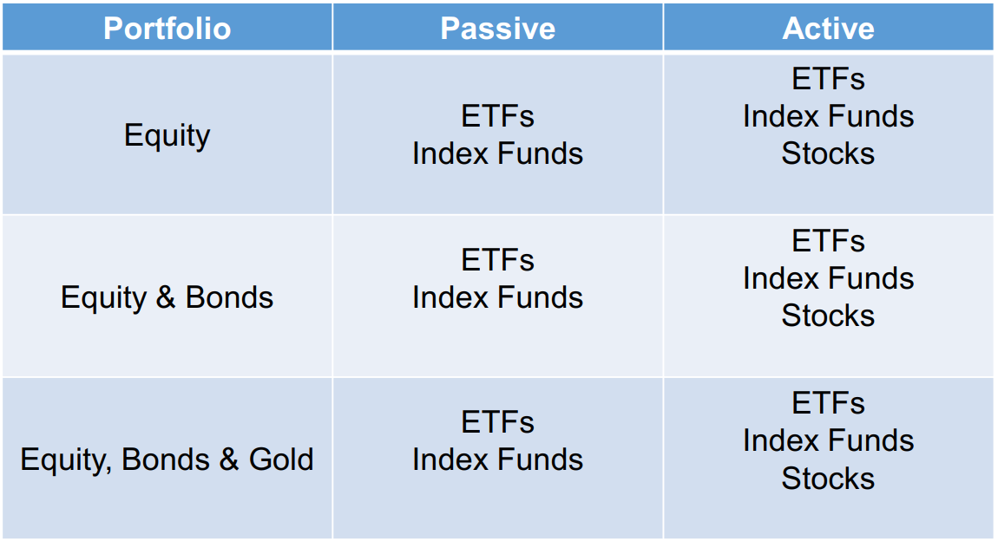
If you selected to be an active investor, then you should choose your activity level from the table shown below. Do you just want to actively select your assets allocation (i.e. percentage of each sector)? Or would you even go deeper and select specific securities in a sector? Would you like to do rebalancing? Tactical asset allocation? We will talk about all these shortly.
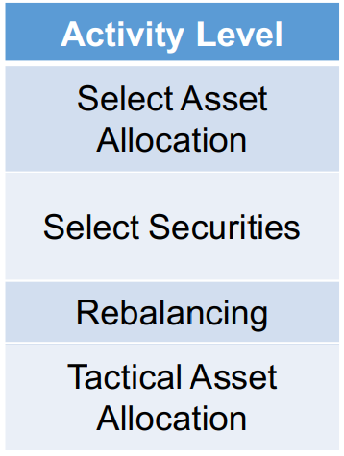
Making portfolio decisions is not easy. At the end of the course, you may still not be 100% sure of what to decide for your portfolio. You can initially choose a simple portfolio until you gain more and more understanding. If you are still unsure, you can better go to an investment advisor that can help you craft your portfolio. However, bear in mind that this advisor will charge you fees, and we have seen in the excel sheet how fees can really reduce your profits. So, think well!

Mutual Funds vs Index Funds and ETFs
Remember that we said that an index fund is a fund that passively replicates the performance of an index. Accordingly, an index fund has low fee. On the other hand, a mutual fund has active managers and analysts that actively try to beat the market. The reason why we don’t include mutual funds in our portfolio decisions is that statistics show that mutual funds are no way better, they don’t beat the market! Check this article in 2019, 92% of mutual fund managers trail/lag the S&P500 index for the last 15 years! But why does this happen? Because the fees of an active fund is much higher than an index fund. So, when you invest in a mutual fund, even if you beat the market in a given year, you are not earning more because you are paying higher fees. Furthermore, you can be even making less returns than the market because active funds invest in many many assets (e.g. 50 assets). So, they are actually getting closer and closer to the S&P500 performance. So, you find yourself paying more and doing the same performance as the market, so effectively you are making less profit.

Efficient Market Hypothesis (EMH)
This hypothesis has been historically known for a very long period and it has been always arguable. It has 3 different forms that are mentioned in this pdf. In conclusion, this hypothesis states that you can’t beat the market because, for you to try to beat the market, you will use data and information about the company (e.g. financial statements, PE, PB, etc) that everyone else knows. So, you can’t simply make profit using something that everyone else knows. One form of the hypothesis even goes further and say that you can’t beat the market even if you know information that are not public (i.e. you are a company’s insider). However, many well-known investors like Warren Buffett and Ray Dalio do not agree with this hypothesis because they actually beat the market consistently for many years using the public information available.

Expectations
What makes investing decisions really hard is that everyone else is thinking how to make profits just like you! So, you might think that Tesla will dominate the vehicles market in the future and electric cars will be everywhere, so does everyone else! In this case, the price of Tesla’s share will go up, not because it is making great earnings today, but because everyone “expects” that it will in the future. For example, people expect Tesla’s earnings per share will be $1 for example. If Tesla’s earnings per share in the future is exactly $1, then Tesla’s share price will not go up because it was already valued at this expectation, so you won’t make profit! You make profit only when reality exceeds expectations, which is when a company is undervalued. A great example that you indeed lived is TMGH. After the Ras Al Hekma project, everyone expected that TMGH profits will skyrocket in the future because of this project, so TMGH share price skyrocketed. Did it go up because TMGH’s earnings suddenly increased? No, it is just because people anticipate that the earnings will increase in the future. So, if you are thinking about whether you should invest in TMGH or not after its share price has already skyrocketed, you should ask yourself: “Is the company now undervalued and, in the future, the company’s earnings will exceed people expectations? Did the people overvalued the company and it won’t make as many earnings in the future?”. So, always remember, “stock prices are all about expectations”.

Passive vs Active Investing
- Passive investing: you are getting your fair share of the market returns. If the market goes up, you earn as much. If it goes down, you lose as much.
- Active investing: you are trying to beat the market. You can only achieve this by being differently diversifying than the market and thus take on the risk of achieving less return than the market.

Passive All-Stock Portfolio
We will now discuss passive investing. Let’s get back to this table:
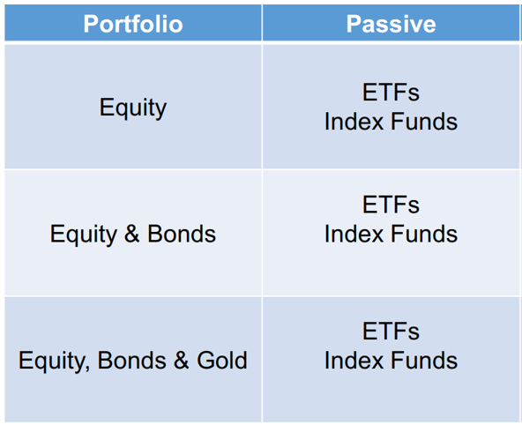
Mohsen Hassan advice:
- if you are under 40 and retiring at 60+, choose an equity-only portfolio. Why? Because, on the long run, equity outperforms bonds and gold. The problem with equity is that stocks are volatile; one year the market may make high profit, but one other year it might lose. But on the long run, it will make higher profit on average compared to bonds and gold. So, if you are under 40, you still have time to benefit from equity’s higher profit on the long run regardless of their volatility. So, bear in mind that, by investing in equity, you are ready to leave the money you are investing for at least 5 years; if you need the money you are investing in equity soon, then investing in equity is not for you.
- Of course, it is undoubtful that it is advised that you take a certain percentage of your monthly salary and invest it in stocks. But what if you have a bulk of money (e.g. bonus, inheritance, etc)? Should you invest it regularly as you do with your salary, or should you put it all once in the stock market? This is a debatable topic that compares “Dollar-Cost Averaging (DCA)” and Lump-Sum” strategies. Read this and this. Watch this and this. Read this and this.
- We said you should be consistent and buying stocks on regular basis. When the market crashes, many people stop buying while this is actually the best time to buy! It is like there is a discount! For example, when the pandemic broke out in 2020, people stopped buying stocks. This was actually one of the best times to have bought stocks because the market rebounded after. Actually, you as a young investor, you should wish that the market crashes because you are still young and you want to buy more stocks at cheaper prices!

Active Asset Allocation
Let’s now talk about active investing. As we said, the activity levels are as shown below:

We will now talk about the first level, actively selecting asset allocation. We said that the S&P500 has a certain different percentage of each sector. If you decided to choose a different allocation than that of the market, then you are said to be actively selecting asset allocation.
So, let’s say we have 3 investors that are trying to actively beat the market as follows:
- He decides to invest in the top 80 companies in the S&P500 that pay dividends SPYD ETF.
- He decides to invest in large US value stocks RPV ETF.
- He decides to invest divide his portfolio equally between technology (XLK ETF), healthcare (XLV ETF), consumer staples (XLP), and consumer discretionary (XLY) sectors only.
Now, let’s compare these 3 portfolios together to the market:
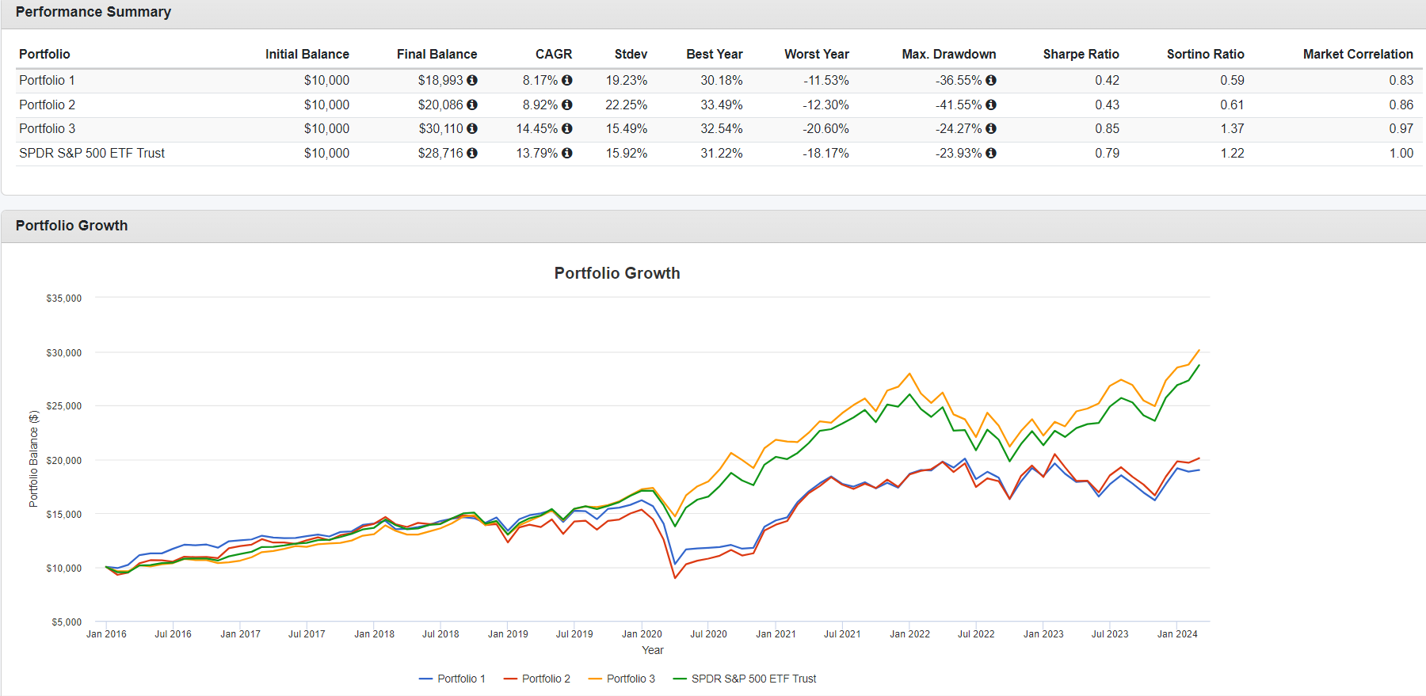
As you can see, portfolio 1 and 2 has less performance compared to the market. Only the third portfolio has beaten the market. This shows you that choosing your portfolio such that you beat the market is not an easy task, and you might end up performing worse than the market. Also, portfolio 3 showing better performance than the market doesn’t mean it will in the future. So, even if you are willing to be an active investor, you should start passive and slowly turn active as you learn more. Where can you learn? From the news. Here are some resources:
- The New York Times.
- The Wall Street Journal.
- Bloomberg.
- Morningstar.

Active Security Selection
Someone who selects the securities he is investing in is said to be actively selecting securities. Of course, he first selects his asset allocation (e.g. I will invest in tech and energy sectors only), then he selects specific securities.
Now, assume someone decided to invest in the technology sector only, this is his asset allocation. Then he decided to invest in the FAANG (i.e. Facebook, Amazon, Apple, Netflix, and Google) companies only. Let’s compare this portfolio to the market:
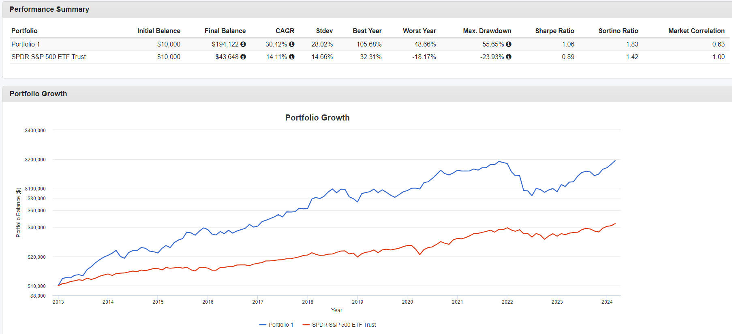
It is clear that this portfolio outperformed the market by much. However, does this trend will remain the same in the upcoming years? Nobody knows!
Selecting the securities that you invest in is not an easy task. It requires a huge amount of effort. In fact, you need to take a bachelor degree and many courses to be able to analyze different securities.

Rebalancing
Assume that from your active asset allocation and security selection, you decided your portfolio will equally constitute only 2 stocks as follows:
Stock | Portfolio Allocation | Share Price | No. of Shares Owned | Money Invested
A | 50% | $50 | 100 | $5000
B | 50% | $5 | 1000 | $5000
Now, assume stock A did well that the share price increased to $10, while stock B did bad that its share price dropped to $25. Here is your portfolio now:
Stock | Portfolio Allocation | Share Price | No. of Shares Owned | Money Invested
A | 20% | $25 | 100 | $2,500
B | 80% | $10 | 1000 | $10,000
See? Due to the fluctuation in stock A and B performance, their portfolio allocation changed from what you decided at the beginning (from 50/50 to 20/80). This is where rebalancing comes in. If you decided that you would like to actively rebalance your portfolio, then you would say “So, I currently have $12,500 invested in my portfolio. To equally divide them between stock A and B, each stock should constitute $12,500 x 0.5 = $6,250 of my portfolio. Accordingly, I will sell $10,000 - $6,250 = $3,750 of stock B and use them to buy stock A”. So, after rebalancing:

Stock | Portfolio Allocation | Share Price | No. of Shares Owned | Money Invested
A | 50% | $25 | 250 | $6,250
B | 50% | $10 | 625 | $6,250

But what is the logic behind rebalancing? The idea is that you sell the stock that increases and buy the one that decreases; you are selling high and buying low. Of course, rebalancing may and may not be great depending on the performance of the two stocks in the future. For instance, consider the following scenario:
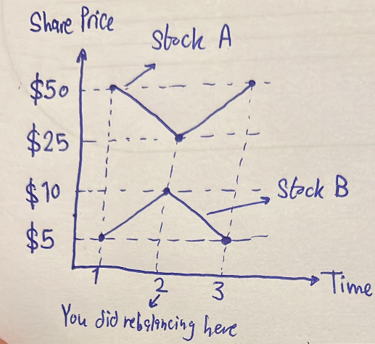
At time 3:
Stock | Portfolio Allocation | Share Price | No. of Shares Owned | Money Invested
A | 80% | $50 | 250 | $12,500
B | 20% | $5 | 625 | $3,125
So, your portfolio now worth $12,500 + $3,125 = $15,625. If you haven’t done rebalancing, you would still have had 100 shares of stock A and 1000 shares of stock B, so your portfolio would have been worth 100 * $50 + 1000 * $5 = $5,000 + $5,000 = $10,000. Rebalancing was the perfect scenario here, right? You sold stock B before it drops, and you bought stock A before it goes up, perfect.
Now, consider the following scenario:
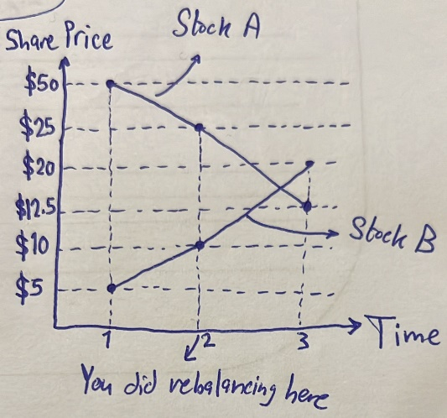

At time 3:
Stock | Portfolio Allocation | Share Price | No. of Shares Owned | Money Invested
A | 20% | $12.5 | 250 | $3,125
B | 80% | $20 | 625 | $12,500
So, your portfolio now worth $12,500 + $3,125 = $15,625. If you haven’t done rebalancing, you would still have had 100 shares of stock A and 1000 shares of stock B, so your portfolio would have been worth 100 * $12.5 + 1000 * $20 = $1,250 + $20,000 = $21,250. Rebalancing was not a good idea here, right? You sold stock B expecting that it would drop, but it continued to increase, and you bought stock A expecting that it would increase, but it continued to decrease.
This tells us that “Rebalancing is perfect when the stock prices are zigzagging”. This is why Mohsen Hassan’s advice is: do rebalancing on a sector basis, not stock basis. That is, rebalance every now and then across different sectors, not across different stocks. Why? Because sectors are guaranteed to zigzag (remember the business cycle?), but stocks can continue to increase/decrease for a very long time. This is what actually mutual funds do when they for example say “our mutual fund invests 25-30% in the energy sector, 30-40% in the health care sector, and 30-45% in the technology sector”. What happens when a sector exceeds what they are stating in their prospectus? They simply do rebalancing to maintain the same percentages.

Tactical Asset Allocation (TAA)
Tactical Asset Allocation (TAA) is more popular when you have equity-and-bonds or equity-bonds-gold portfolios. So, what is TAA? Assume one decided his portfolio as follows:
Sector | Percentage
Technology (XLK) | 25%
Consumer Staples (XLP) | 25%
Health Care (XLV) | 25%
Consumer Discretionary (XLY) | 25%
And as we said, as the stocks begin to play, these percentages will change, so a trader might do rebalancing to maintain the same percentages. However, assume there is a market crash. Since technology and consumer discretionary sectors are cyclical sectors, they might be down more than health care and consumer staples sectors. Accordingly, the trader might consider totally changing his portfolio’s percentages because he sees that it is an opportunity to buy more in the technology and consumer discretionary sectors. Accordingly, he might change his allocation as follows:
Sector | Percentage
Technology (XLK) | 30%
Consumer Staples (XLP) | 20%
Health Care (XLV) | 20%
Consumer Discretionary (XLY) | 30%
This is what is called TAA; TAA is an active management portfolio strategy that shifts the percentage of assets held in various categories to take advantage of market pricing anomalies or strong market sectors.
So, we can say: rebalancing is meant to maintain the percentages of assets held in your portfolio all the time, while TAA is meant to dynamically change the percentages of assets based on market circumstances.

Simulation Account
Most brokers offer a simulation account for you to try out their platform without real money. This simulation account is a good opportunity for you to try out different strategies with fake money before doing so with your hard-earned money. You can create a simulation/paper account on Interactivebrokers.

Investing vs Trading
This is the most important video of the whole course. I suggest you go watch it again!
Take-home note: trading is for professionals only whose profession is trading. Since you are an Engineer not a trader, never ever trade, just invest!

